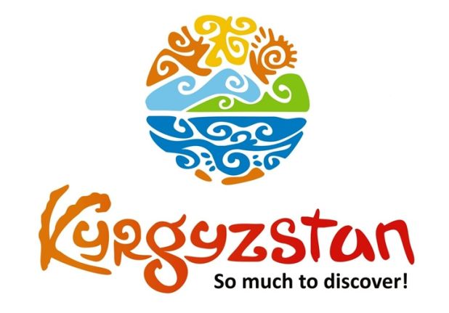**Nomad’s Way Tour**

Country: **Kyrgyzstan**

Period: **June - September**

**Days: 10 / Nights: 9**

Organizing any complexity of tours to Issyk-Kul, Son-Kul, around Kyrgyzstan and Central Asia. We guarantee you high quality of service and individual approach!

More than any other Central Asian people, the Kyrgyz have been attached to their traditional way of life as nomads. This tour will show you the hospitality of Kyrgyz people when you visit them at yurts where they live; introduce to [nomadic way of life:](https://www.youtube.com/watch?v=fEuw4Hl04hU) milking mares, cooking food on fire…and taste homemade national dishes…

#### [Day 1: Airport - Bishkek (30 km/50 min)](https://concept.kg/en/tours/inbounds/17/#program_collapse_18)

#### 

Upon arrival to Bishkek Airport meet your local driver who will transfer you to city.  
Flight details are to be confirmed – standard check-in to hotel at/after 14:00.  
Afternoon guided city tour of capital’s main highlights: Ala-Too Main Square, open air Art Gallery where you can see paintings of local artists, Oak Park, Panfilov Park, walk through the Erkindik boulevard where you can meet urban people of all ages, Youth Alley, the Statue of Manas - the founder of the Kyrgyz nation is located in front of the Kyrgyz State Grand Philharmonic Hall. The Alley is surrounded by two main universities and it is crowded by students during the semester.

If time permits, finish the tour with excursion to colorful Osh Bazaar where it is possible to feel the real scent of Central Asian culture: visit fruit, dry fruit and souvenir sections. Overnight at hotel.

Meals: independent

#### [Day 2: Bishkek - Chon-Kemin (135 km/3 h)](https://concept.kg/en/tours/inbounds/17/#program_collapse_19)

#### 

In the morning meet your guide/driver and depart to Chon-Kemin Valley, a popular tourist destination for its beautiful unspoiled nature. On the way, stop to visit historical Burana Tower, a minaret from the 11th century and an open air museum of Balbals (stone warriors). You can climb to the top of the minaret and enjoy the view of the valley.  
Arrival to Kalmak-Ashuu village and check-in to a charming guesthouse run by a local family where you can feel home-oriented warm atmosphere.  
After lunch spend the rest of the day hiking to Kalmak-Ashuu Gorge.  
In the evening you can take a walking tour to area next to the guesthouse and get to know how local people live. In particular, you can watch them take care of home cattle, milk cows and cook food.  
Available activities upon request:- Boorsok show (small pieces of dough fried in oil, Kyrgyz national bread)- Horseback riding

Meals: breakfast, lunch, dinner

#### [Day 3: Chon-Kemin - Karakol (300 km/5 h)](https://concept.kg/en/tours/inbounds/17/#program_collapse_20)

#### 

After the breakfast, leave towards Karakol through the Issyk-Kul Lake’s Northern shore.  
Spend some time in Cholpon-Ata town near the lake and visit Ruh-Ordo cultural center, open air Petroglyphs Museum.  
Enjoy the scenic road to Karakol located at far east of the lake.  
Upon arrival to Karakol, check-in to a guesthouse.  
In the afternoon short city tour: visit beautiful Russian Church made entirely of wood (built without nails), the Dungan Mosque (Dungan’s are minority group of Chinese Muslims living in this region and they originally come from Western China), the museum of Przhewalski, who was renowned Soviet explorer of Central and East Asia. Further, visit one-village-one-product local shop for handmade souvenir products made by local women of the region. This shop is run by the association of local women who produce wide range of products starting from wild berry jams, handicrafts, herbal soaps and other souvenirs, all using products and materials found in the Issyk-Kul region.

Meals: breakfast, lunch, dinner

#### [Day 4: Karakol – Jeti-Oguz (40 km/1.5 h)](https://concept.kg/en/tours/inbounds/17/#program_collapse_21)

#### 

It is possible to visit Sunday Animal Market (functions only on Sundays) which opens early in the morning.   
After the breakfast, drive to Jeti-Oguz, a lush valley with some striking red sandstone rock formations including the “Seven Bulls” from which the valley takes its name.

After some sightseeing, we proceed to Kok-Jayik (the Valley of Flowers). Accommodation at yurt camp. In the afternoon (after lunch at yurt camp) hiking tour to surrounding mountains and waterfall.

Meals: breakfast, lunch, dinner

#### [Day 5: Jeti-Oguz - Kochkor (280 km/5 h)](https://concept.kg/en/tours/inbounds/17/#program_collapse_22)

#### 

After breakfast at yurt camp, you will drive through the Southern shore of the Issyk-Kul Lake to Kochkor village.   
On the way, excursion to Barskoon valley. Rare shrubs and steppe grasses grow at the beginning of the Gorge. Huge Tian-Shan spruce trees rise on both slopes of the Canyon. Along the road running through the gorge of Barskoon there are unusual monuments such as the Soviet truck on the platform and a bust of the first cosmonaut Yuriy Gagarin, who vacationed on the southern shore of the Issyk-Kul Lake after his flight into space. From the gorge you can see the snowy peaks of the surrounding mountains, the highest and most beautiful ones are the Peak of Panfilov Heroes (4610 m) and the Peak of the World Peace Council (4310 m). Barskoon Gorge is famous for its cascading waterfalls. The most picturesque have interesting names: Tears of a Bars, Beard of an Old Man, Splashes of Champagne and Cup of Manas.

Afterwards, visit Skazka (Fairy Tale) Canyon. Lunch-boxes.  
The canyon was named after its bizarre rocky landscape, which for many years has been transformed by wind into various sculptures and formations. Some structures have been named for their similarity to the well-known objects and places. For example, one set of ridges in the canyon is called the "The Chinese Wall" due to its similarity to the Great Wall of China. Visitors can also find what appear to be the statues of hippopotamus, snakes, dragons, sleeping giants and even whole castles. Not only do the rocks have different shapes, but also various colors.  
Arrival to Kochkor village and accommodation at a family run guesthouse.  
If time permits, visit Altyn-Kol (Golden Hands) - a cooperative shop of women from the surrounding villages where they sell the felt products they make.   
Depending on time, today or the next morning, participate in a felt craft show with some local women.

Meals: breakfast, lunch-box, dinner

#### [Day 6: Kochkor - Song-Kul (110 km/2 h)](https://concept.kg/en/tours/inbounds/17/#program_collapse_23)

#### 

After the breakfast, drive to the Song-Kul Lake.  
Song-Kul Lake lies at an altitude of 3016 m and has an area of about 270 km² and volume of 2.64 km³. Lake's maximum length is 29 km, breadth about 18 km, and depth 13.2 m. It is the second largest lake after the Issyk-Kul Lake and the largest fresh water lake in Kyrgyzstan. Its name is popularly considered to mean “following lake.” There are broad beautiful pastures and mountains surrounding the lake.  
Dinner and overnight at the yurt camp.  
Note: Accommodation conditions at yurt camp are very traditional, meaning that person will be able to share toilet outside of the yurt and be able to experience Kyrgyz rural lifestyle firsthand. Single accommodation is not available, 3-6 pax per yurt.

Meals: breakfast, lunch, dinner

#### [Day 7: Song-Kul Lake](https://concept.kg/en/tours/inbounds/17/#program_collapse_24)

Full day rest at Song-Kul lake and hiking to nearby mountains.  
You can visit Kyrgyz nomads and their families and get to know true nomadic lifestyle, watch them milk cows and mares, prepare dairy products from the milk and a national Kyrgyz drink - Kymyz (fermented mare’s milk), cook food and take care of households. Even if local people do not speak your foreign language, they will try to show their hospitality and be nice, invite you into their yurts and offer bread with Kymyz.  
Overnight at yurt camp.

Meals: breakfast, lunch, dinner

#### [Day 8: Song-Kul - Kyzyl-Oi (310 km/6-7 h)](https://concept.kg/en/tours/inbounds/17/#program_collapse_25)

#### 

After the breakfast, drive to Kyzyl-Oi village.   
Overnight at a local homestay.

Meals: breakfast, lunch, dinner

#### [Day 9: Kyzyl-Oi - Bishkek (170 km/5 h)](https://concept.kg/en/tours/inbounds/17/#program_collapse_26)

#### 

Transfer to Bishkek through Too-Ashuu mountain highway Pass (3586 m). Stop at the Suusamyr Valley to taste Kymyz (fermented mare’s milk). The road from Bishkek to Suusamyr is one of the most stunning in the country. It wounds up and down several mountain passes above 3500 meter before opening up to the green pastures of the Suusamyr Valley where shepherds stay with their livestock.  
Arrival to Bishkek.  
Afternoon free time for resting, shopping and independent exploration of the city.  
Overnight at a hotel.

Meals: breakfast, lunch

#### [Day 10: Bishkek - Manas Airport](https://concept.kg/en/tours/inbounds/17/#program_collapse_27)

Departure day.

Transfer to the Airport for the departure flight.

Meals: No

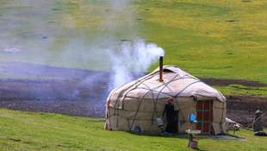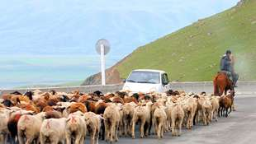

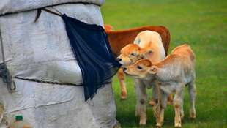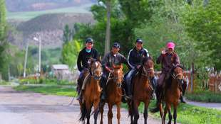

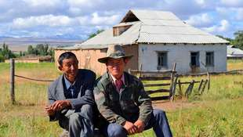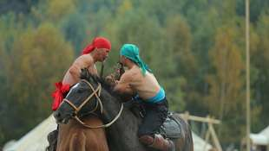

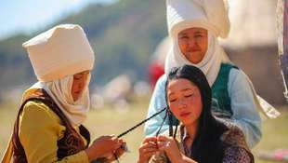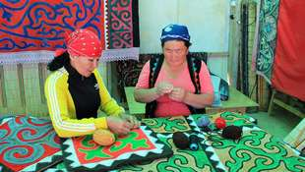

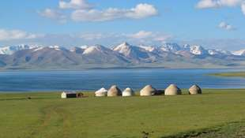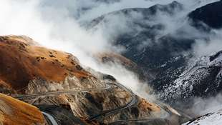

| **GROUP SIZE** | **PRICE IN USD/PER PERSON** |
| --- | --- |
| 2 | 1760 USD |
| 3-4 | 1510 USD |
| 5-6 | 1215 USD |
| 7-8 | 1090 USD |
| Supplementary pay for single accommodation | 115 USD |

| **PRICE INCLUDES** |  |
| --- | --- |
| Twin based accommodation | Bishkek - 3* Hotel (2 o/n) Chon-Kemin - homestay (1 o/n) Karakol - guesthouse (1 o/n) Jeti-Oguz - yurt camp (1 o/n) Kochkor - guesthouse (1 o/n) Song-Kul - yurt camp (2 o/n) Kyzyl-Oi - guesthouse (1 o/n) |
| *Side note:* | *Accommodation conditions at yurt camp are very traditional,  meaning that person will be able to share toilet outside of the yurt and be able to experience Kyrgyz rural lifestyle firsthand.  Usually 3-6 pax per yurt (during the high season) Single accommodation can be arranged if there is some vacant space* |
| Transport | Comfortable car with a/c |
| Guide services (Eng/Russ) | Included |
| Meals | Meals mentioned in the program |
| Entrance fees | According to the program |
| Water | 1 liter/person/day |

| **PRICE EXCLUDES** |
| --- |
| International flights |
| Visa/letter of invitation to Kyrgyzstan (if require) |
| Early/late check-in/check-out |
| Meals not mentioned in the program |
| Personal expenses |
| Horsebackriding in Chon-Kemin |
| Boorsok show in Chon-Kemin |

**Contact information:**

[www.travelscruiser.com](http://www.travelscruiser.com)

Phone (24/7): +996 …………., +996 ……….

E-mail: [info@travelscruiser.com](mailto:info@travelscruiser.com)